Your Name here

[Draw your reader in with an engaging abstract. It is typically a short summary of the document. When you’re ready to add your content, just click here and start typing.]
[Document title]
Computer Science NEA

Contents
Evaluation 2

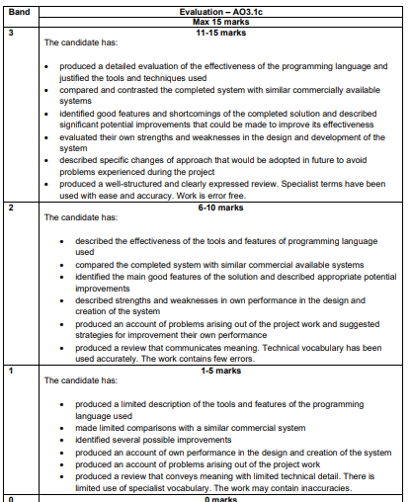

This is for your reference only and needs to be deleted when it is handed in as a final copy.

Please also delete any of my comments from the sections below, on final hand in

Evaluation
You need to cover the following, each should have a separate paragraph.
- Effectiveness of the programming language and the tools you have used.
- Compared your system to the commercially available systems in your investigation
- Identified good and weaker aspects of your system, identifying what you would have liked to have done better. You don’t actually have to make these improvements so you can be imaginative!!
- Explained your strengths and weaknesses in the design and development of the system
- Identified any personal changes you would make if you were asked to repeat the process to avoid any of the above weaknesses.

